AKT1 Antibody
- Antibody basic information
Cat No. | Contents | Isotype | MW of target
NBP1-51602 |  | Mouse IgG1 | 60kDa

- Testing result
AKT1 can be detected in COS cells (see reference). So we use lysates from COS cells for WB assay.

1) Western blot result at 1:1000 dilution of AKT1 antibody.
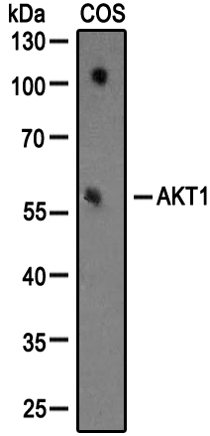
Western blot analysis of extracts from COS cells using AKT1 antibody at dilution of 1:1000.

2) Western blot result at 1:100 dilution of AKT1 antibody.
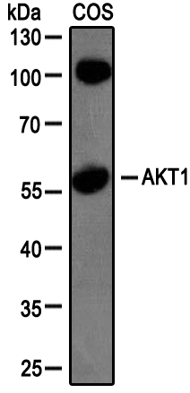
Western blot analysis of extracts from COS cells using AKT1 antibody at dilution of 1:100.

- Conclusion
NBP1-51602 detected endogenous level of AKT1 in COS cell lysates in WB at dilution of 1:1000.

