AKT1 Antibody
- Antibody basic information
Cat No. | Contents | Isotype | MW of target
NBP1-51602 |  | Mouse IgG1 | 60kDa

- Testing result

IHC result at 1:50 dilution of AKT1 antibody.
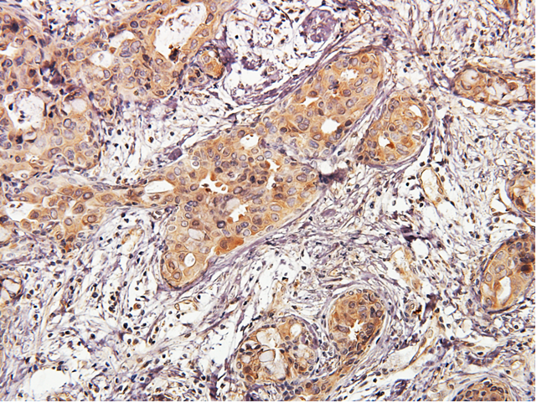
IHC analysis of paraffin-embedded human breast carcinoma using AKT1 antibody at dilution of 1:50.

IHC result at 1:25 dilution of AKT1 antibody.
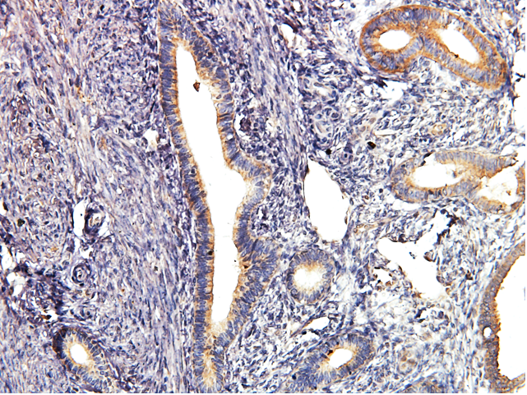
IHC analysis of paraffin-embedded human endometrial cancer using AKT1 antibody at dilution of 1:25.

- Conclusion
NBP1-51602 detected endogenous level of AKT1 in human breast carcinoma and human endometrial cancer in IHC at dilution of 1:50 and 1:25 respectively.

